Cafeteria Menu Display Portal
Project Documentation
Year:20-2- 2026

Executive Summary
This document describes the Cafeteria Menu Display Portal developed using ServiceNow. The system provides a centralized platform to create, manage, and publish cafeteria menus efficiently. It includes a custom table for storing menu details, a Service Catalog item for submitting new menus, reporting for date-wise tracking, and a UI Action for publishing menus. The solution improves accuracy, reduces manual effort, and enhances visibility of cafeteria menu information within the organization.

1. Problem Statement
The Cafeteria Menu Display Portal is designed to enhance the management, publication, and accessibility of daily and weekly cafeteria menus within an organization. Traditional manual methods of menu management often lead to miscommunication, delayed updates, and lack of historical tracking. This project provides a structured and automated solution using ServiceNow to streamline menu creation, storage, reporting, and publication.

2. Application Development using Studio
The application is developed within ServiceNow Studio as a custom scoped application named 'Cafeteria Menu Display'. Studio enables structured development of tables, catalog items, UI actions, and reports under a single application environment. This ensures modularity, maintainability, and scalability of the system.

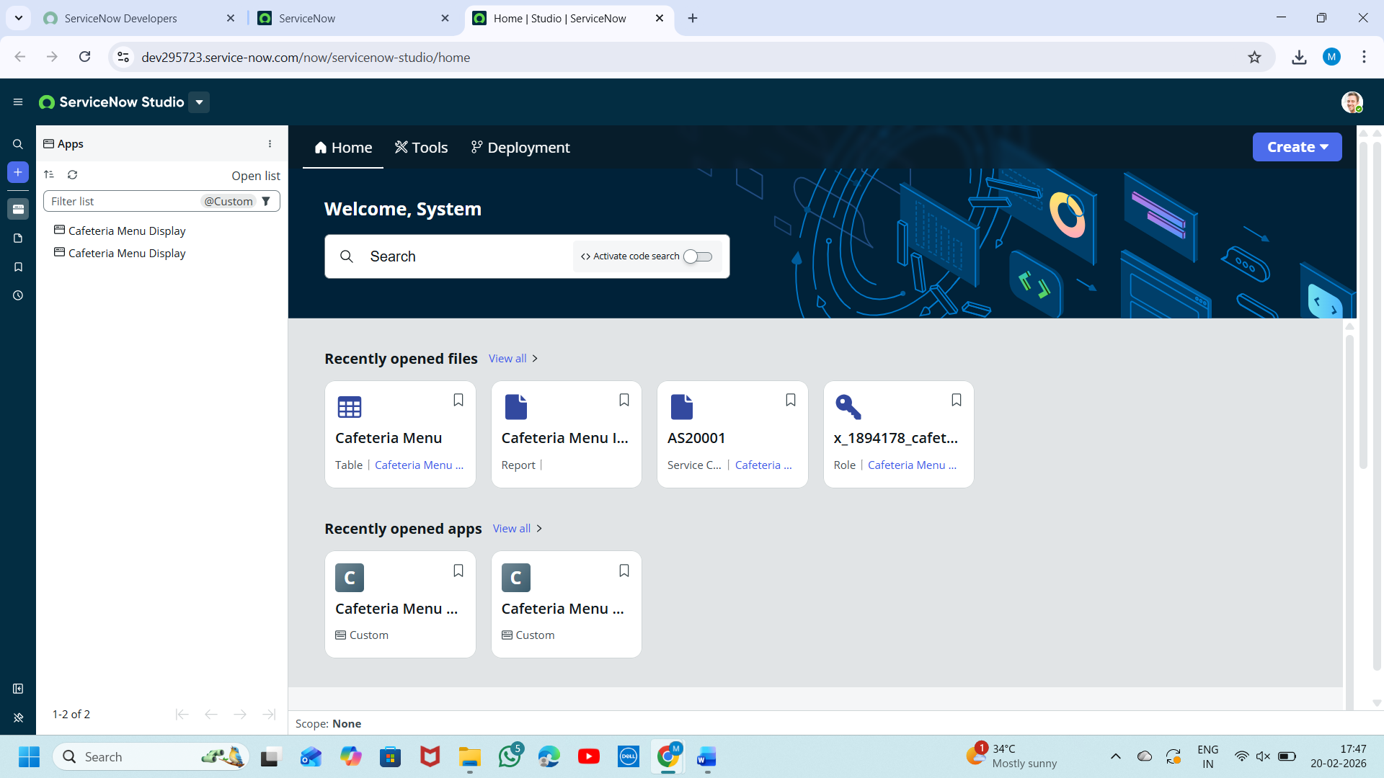

3. Custom Table Design
A custom table named 'Cafeteria Menu Display' is created to store menu records. The table acts as the primary data storage layer of the application.
Key Fields in the Table:
• Menu Name – Stores the name/title of the menu.
• Menu Date – Stores the date for which the menu is applicable.
• Menu Items – Stores detailed list of food items.
• Status – Indicates whether the menu is Draft or Published.

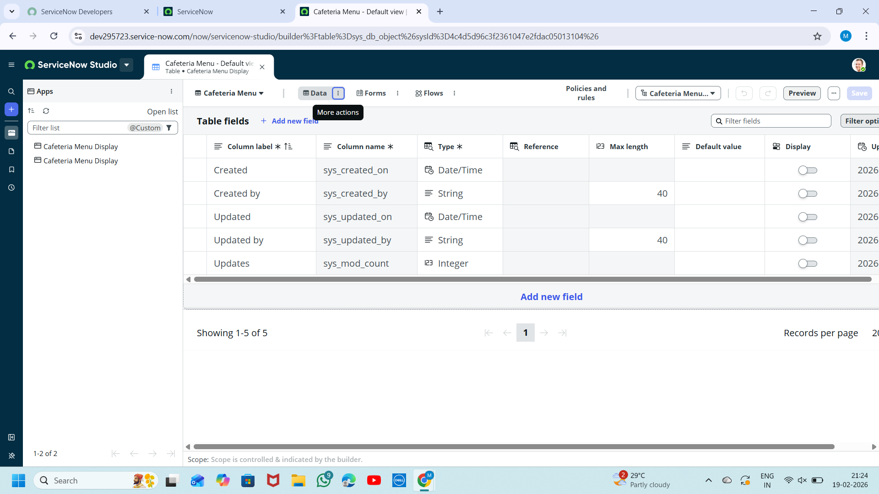

4. Service Catalog Integration
A Service Catalog item titled 'Submit New Cafeteria Menu' is created to allow authorized users to submit new menu details. The catalog form collects structured inputs such as Menu Name, Menu Date, and Menu Items. This provides a user-friendly interface for data entry without directly accessing the table.
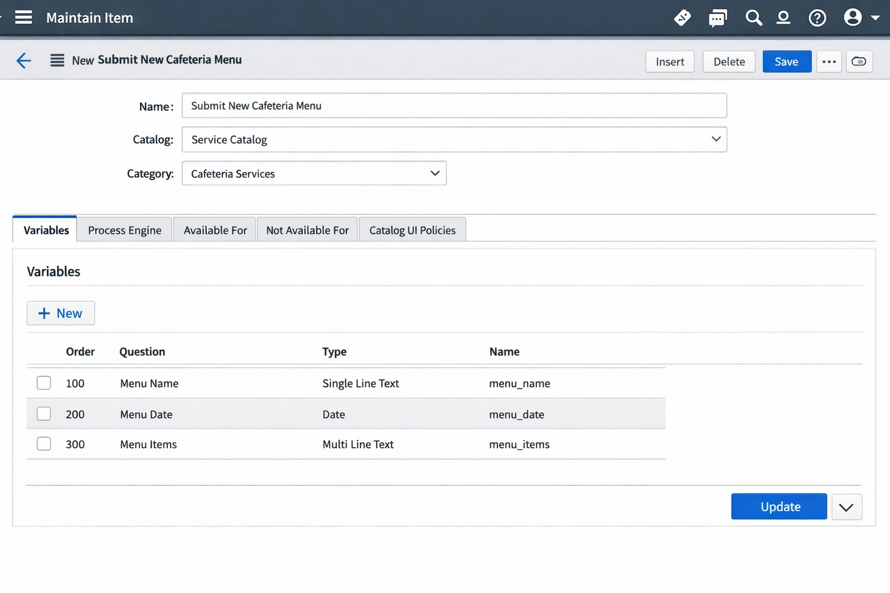

5. Reporting and Dashboard
A report named 'Cafeteria Report' is configured using the Cafeteria Menu table as the data source. The report groups records by Menu Date and displays Menu Date, Menu Name, and Menu Items in a list format. The report is added to the dashboard for quick administrative monitoring and visibility.

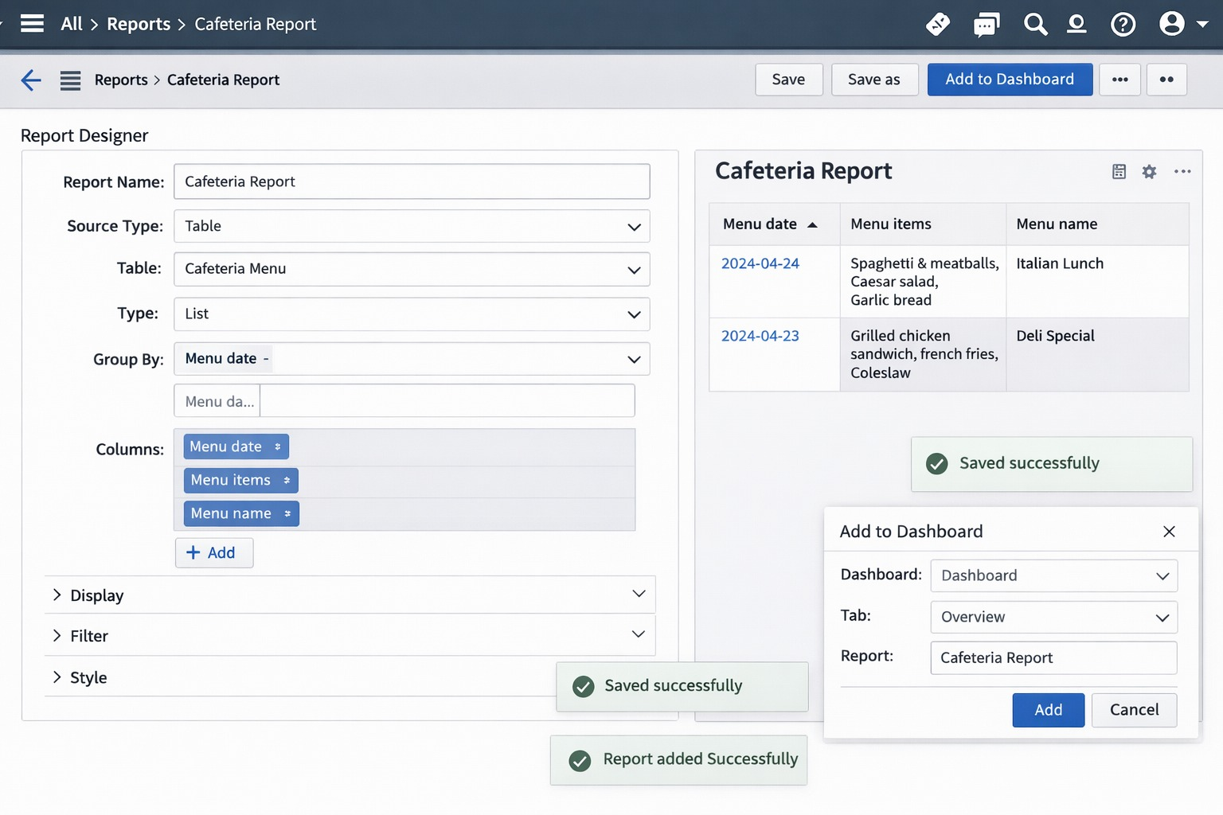

6. UI Action Implementation
A custom UI Action named 'Mark as Published' is implemented to automate the menu publication process. When triggered, the action updates the Status field to 'Published', saves the record, and displays a confirmation message. This ensures controlled publishing and prevents accidental modifications.

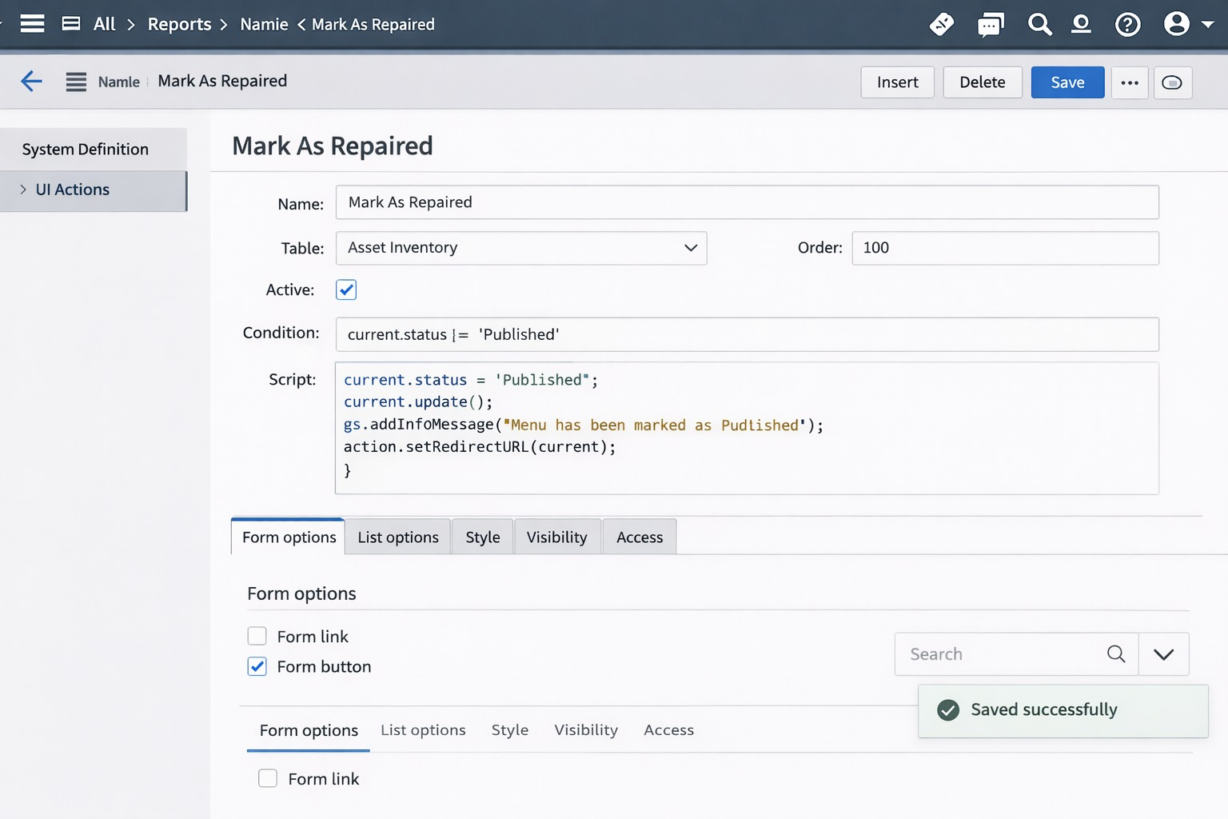

7. Testing and Validation
Testing involves submitting menu details through the Service Catalog and verifying that records are correctly stored in the Cafeteria Menu table. The UI Action is tested by marking a draft menu as Published and validating that the status changes successfully. Reports are verified to ensure accurate grouping and display of data.

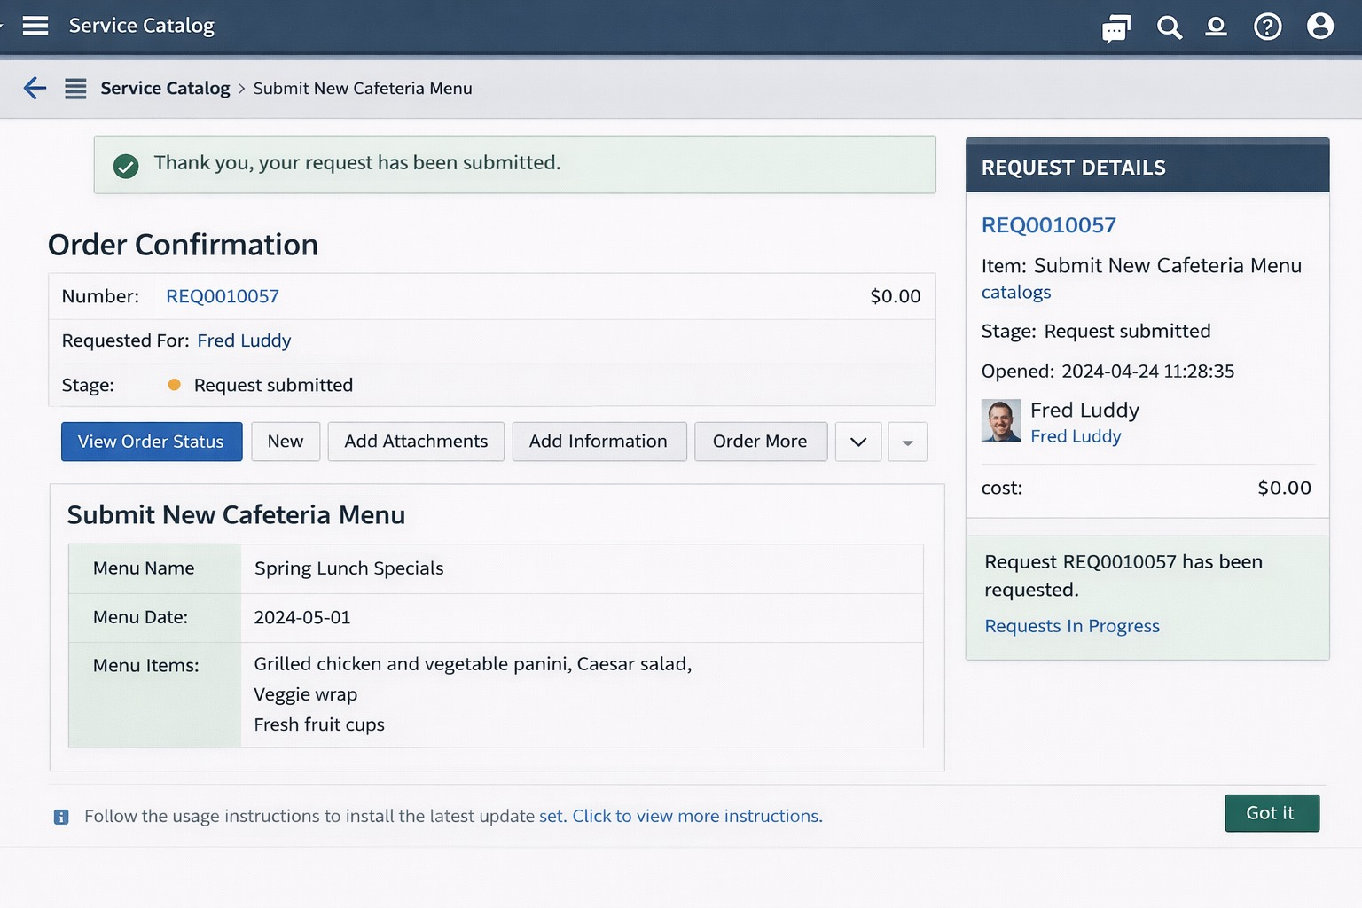

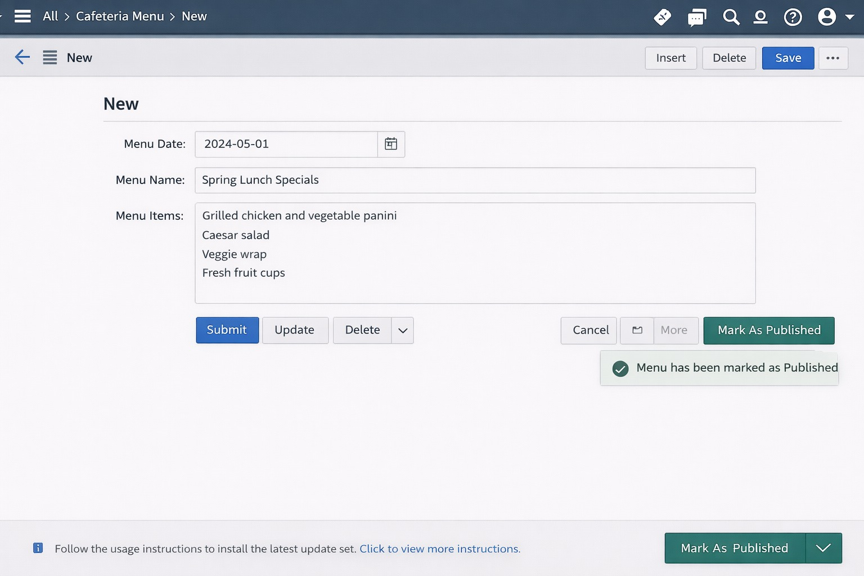

8. Conclusion
The Cafeteria Menu Display Portal demonstrates how ServiceNow can be utilized to build a structured and automated application for cafeteria management. By integrating custom tables, Service Catalog, reports, and UI actions, the system enhances operational efficiency, ensures data consistency, and improves transparency in menu publication.

